**Computer Shop Management System**

**SUBMITED BY**

1. Ankit Kumar Seth



**Department Of Computer Application.**

**K.K.Wagh Arts, Commerce, Science and Computer Science College.**

**Nashik-422003**

**Academic Year 2021-22**



KarmaveerKakasahebWagh Education Society’s

**K. K. Wagh Arts Commerce, Science, & Computer Science College**

**Saraswati Nagar Nashik-422003**

**C E R T I F I C A T E**

This is to certify that,

**Mr.** .Ankit Kumar Sethhas satisfactory completed his their project

Computer Shop Management System as fulfillment in **T.Y.B.B.A.(Computer Application)** Class for the academic year **2021-2022**.

Project Done by: Ankit Kumar Seth

Prof. V.H.Bava

Project Guide

(H.O.D )

Internal Examiner External Examiner

**Index - Website Project**

|  |  |  |
| --- | --- | --- |
| **Sr. No** | **Documentation Content** | **Page No** |
| **I** | **Introduction** | |
| 1 | Motivation | 4 |
| 2 | Problem Statement | 3 |
| 3 | Purpose / Objective and Goals | 3 |
| 4 | Literature Survey | 6 |
| **II** | **System analysis** | |
| 1 | Existing Systems | 6 |
| 2 | Scope and Limitations of Existing Systems | 7 |
| 3 | Project Perspective , Features , Stakeholders | 7 |
| 4 | Requirement Analysis -  Functional requirements, Performance requirements,  Security requirements etc | 9 |
| **III** | **System Design** | |
| 1 | Class Diagram | 10 |
| 2 | Use Case ,Activity Diagram , Sequence Diagram , Deployment Diagram | 13 |
| 3 | User Interfaces | 14 |
| **IV** | **Implementation details** | |
| 1 | Software / Hardware Specifications | 26 |
| **V** | **Outputs and Reports Testing** | |
| 1 | Screenshot and Report | 30 |

**Motivation**

We own our sincere gratitude to all those people who have given us their constant support and encouragement without which our project report would not have reached this stage.

We would like to express our thanks to Prof V.H Bava for her advice and encouragement. She has been a pillar of strength right through the project till the preparation of this report and helped by boosting morale, so we could surmount the difficulties that came across during completion of this project.

We would like to express our gratitude to Dr.A.P.Rajput, Principal, K.K.Wagh Arts, commerce, science and Computer Science College and Prof.Vijayshri Bava, Head of Computer Application department for the support and the infrastructure they have provided, so that we could successfully complete the project on time.

Last but not the least, we would like to express our sincere thanks to all staff members and our friends for their help and cooperation in all phases of the project.

1. Ankit Kumar Seth

**Problem Statement**

* The problem with the old system was that the customer was obelized to shop in a particular interval of time .The buyer need to invest a separate schedule for shopping.
* The problem related to shopkeeper was he could not sell his items during non-shopping hours.
* Through the introduction of online shopping the customer as well as the shopkeeper are relieved, since the reach of seller as increased and the buyer could buy anything at any particular time.
* One more important aspect of offline sales was it is very difficult of analyze sales and to draw information like sales in a particular period of time, to manage record of employees and customers and to observe certain trends among customers.

**Purpose**

* The purpose of this website is to provide the seller an online mode to sell his products online and to create a vast customer base.
* This website will resolve few problems of the seller of managing data and finding few information related to his sales.
* This website also provides some extent of security from unauthorized beach into the website without proper authentication.
* The sole purpose of this application is to serve the user and the admin with pleasant user experience and to save time of both the sides.

**Literature Survey**

In the previous system:

* It requires a lot of manual work in management.
* It was difficult to manage records without data inconsistency.
* The data stored was not secure.
* It was very hard to analyze what user activities.

**Existing System**

* In existing system all the information is gathered in registers.
* Existing system management takes time long, tedious, and difficult to perform.
* Existing system has number of flaws like security, issue with time form selling and shopping.

**Limitations of Existing Systems**

* In the existing system the main issue is with handling the date generated every day.
* Existing system lack an efficient security system, due to this the data can be manipulated or stolen by any unauthorized person.
* In this system a lot of management work is required by the manager, this takes lot of time .Also the work becomes tedious to perform since every day work is required to maintain /store information of customers.
* The old school method of selling goods and managing information on paper involved lot risks of date loss , data inconsistence, forgery, etc.
* One more disadvantage of above point it is very difficult to analyze the data (also called as data mining) collected by customers or data about customers to extract something useful to the company.

**Scope**

* The system proposed will be able to resolve most of the issues related to management to a computer shop.
* The system will have option of add to cart and off chores you can buy various components of your computer which includes processor, graphic cards, mother board, RAM , SMPS, Hard disk, SSD, CPU cabinet, mouse and keyboard.
* There will be one modes of payments cash. Online payment option will be available soon.
* Admin will able to see few information related to sales like information of customers how bought any product within any interval of time specified, sales of a particular product, brand.

**Project Perspective**

* This Project can be used by computer shops for managing sales and stock report.
* Also the shopkeeper can go online and take orders from customers.

**Features**

* It will save energy, time and fuel.
* It stores all records permanently.
* Less use of manual work.
* Easy to search and buy.
* Ability of the shop to be open for 24/7 hrs.
* All the daily expenses will be updated in the databse daily.
* All the records of current and ex-staffs will be stored in the databse.
* Also keeps the record of computers sold .
* Any cancelation of the orders also updated.
* Profit and losses will be updated every month and also shows the variations.
* It gives the raises and deviations in the status of the shop in the market.
* It will help to increase business reach.

**Stakeholders**

* Admin
* Customer/Users

**Performence Requirements**

In order to maintain the acceptable speed at maximum number of uploads allowed from a particular customer will be any number of users can access the system at any time. Also connections to the server will be based on the criteria of attributes of the user like his location, and server will be working whole 24*7 times.

**Functional Requirements**

The problem under study is being divided into several modules/functions discussed below to understand the approach to the solution in the broader way:

* **Customer Registration**
* **Welcome and Login Page**
* **Product Category**
* **Product Search Result Screen**
* **View Cart Screen**
* **Order Details Screen**
* **Product Details**
* **Payment Gateway**

**Non-functional Rquirements :**

**Security :**  The system must automatically log out all customers after a period inactivity. The system’s back-end servers shall only be accessible to the authenticated administrators. Sensitive data will be encrypted before being sent over insecure connections like the internet.

**Reliability :** The Reliability of the overall at all times, meaning the user can access it using a web browser, only restricted by the down time of the server on which the system runs. In case of a hardware failure or databse corruption, a replacement page will be shown. Also in case of a hardware failure or databse corruption, backups of the databse should be retrived from the server and saved by the administrator.

**Maintainability :** A commercial database is used for maintaining the databse and the application server takes care of the site. In case of a failure, a re-initialization of the program will be done. Also the software design is being done with modularity in mind so that maintainability can be done efficiently.

**Portability :**  The application in HTML and scripted language based. So the end-user part is fully portable and any system using web browser should be able to use the features of the system, including any hardware platform that is available or will be available in the future. And end-user is use the system or any OS; either it is Windows or Linux. The system shall run on PC, Laptops and PDA etc.

**System Design**

**Class Diagram**

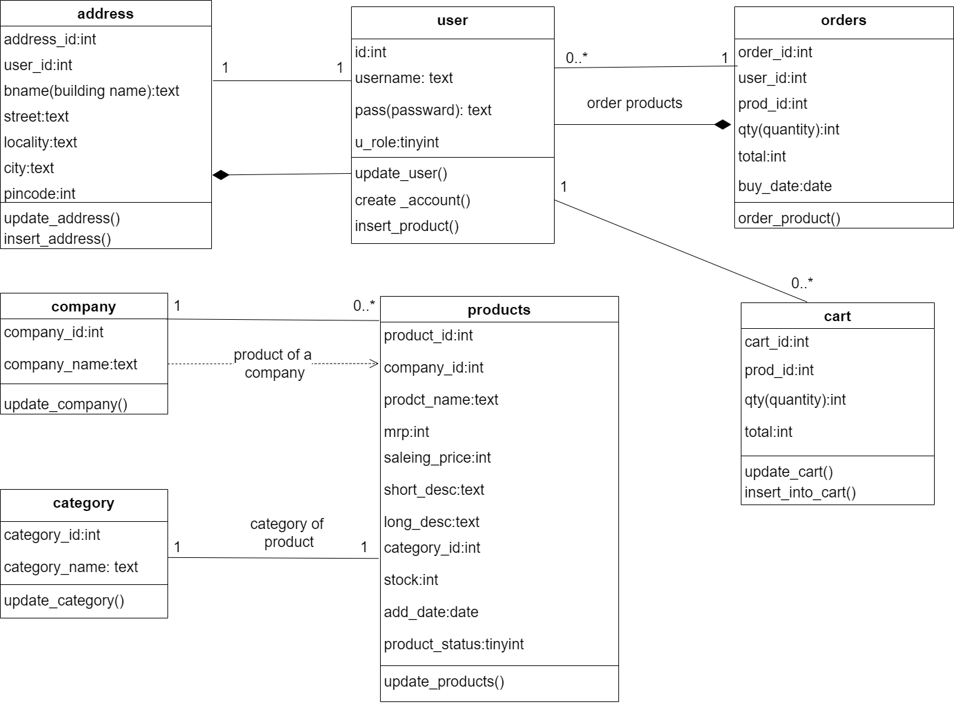

**Use Case Diagram**

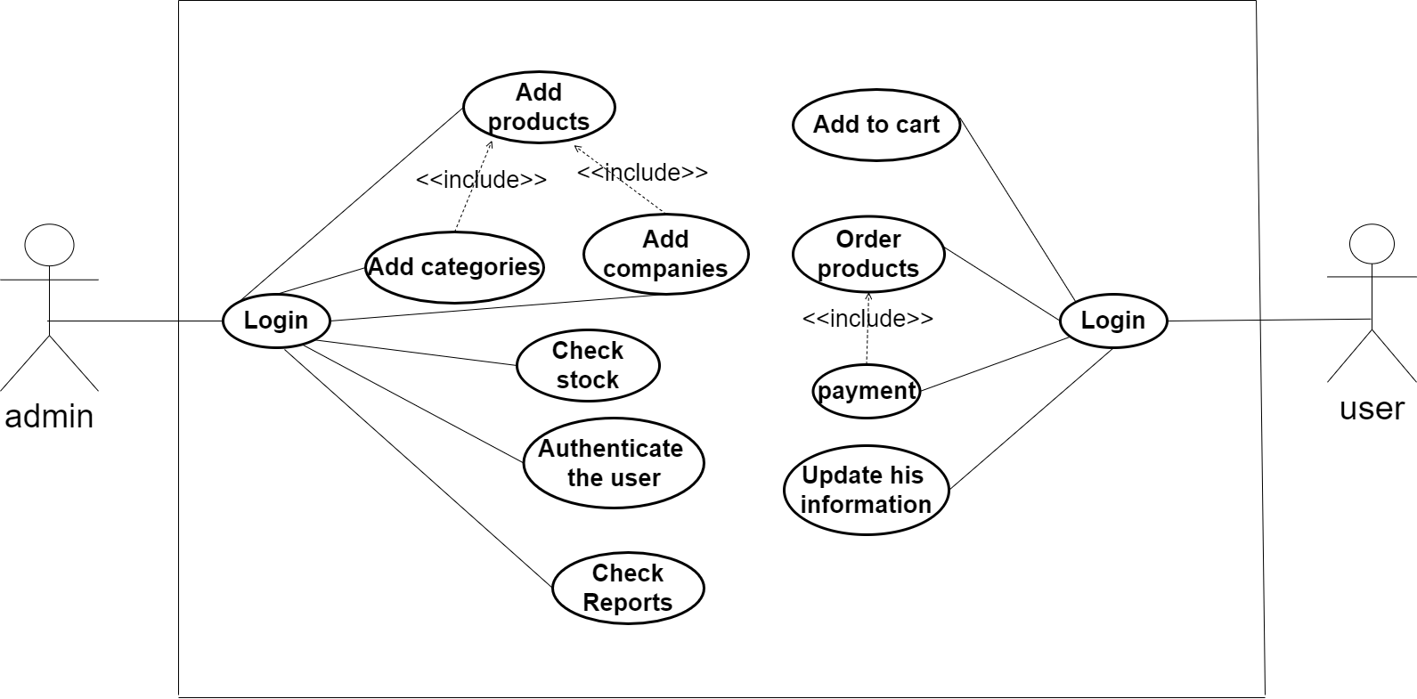

**Deployment Diagram**

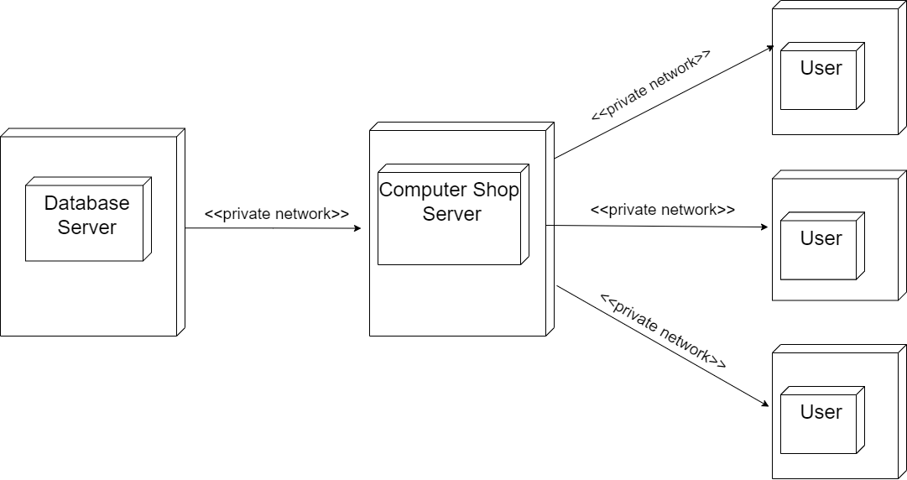

**Activity Diagram**

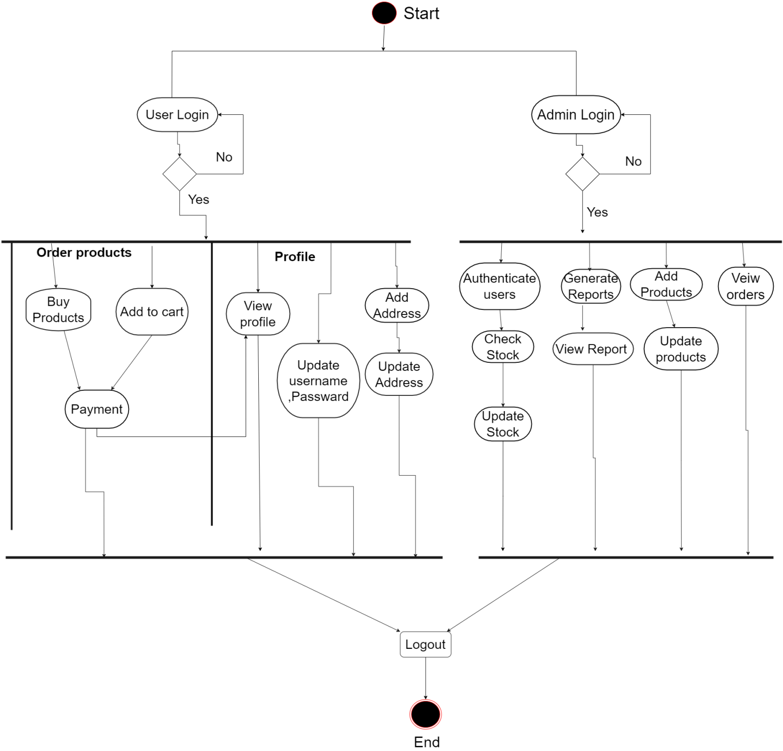

**Sequence Diagram**

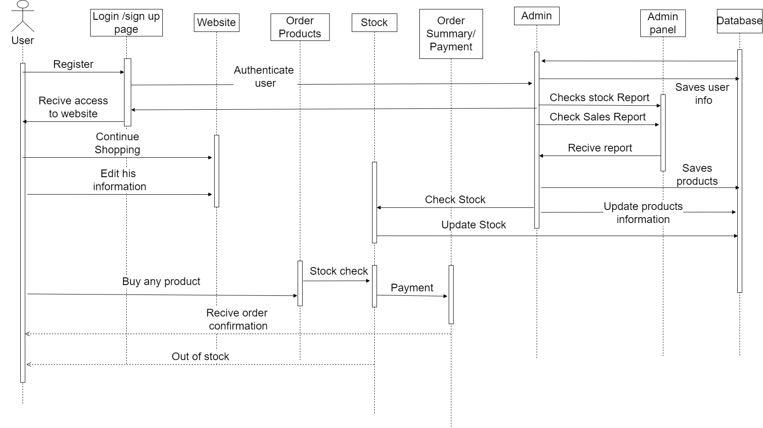

**User Interfaces**

Admin Side:

Sign In / Login:

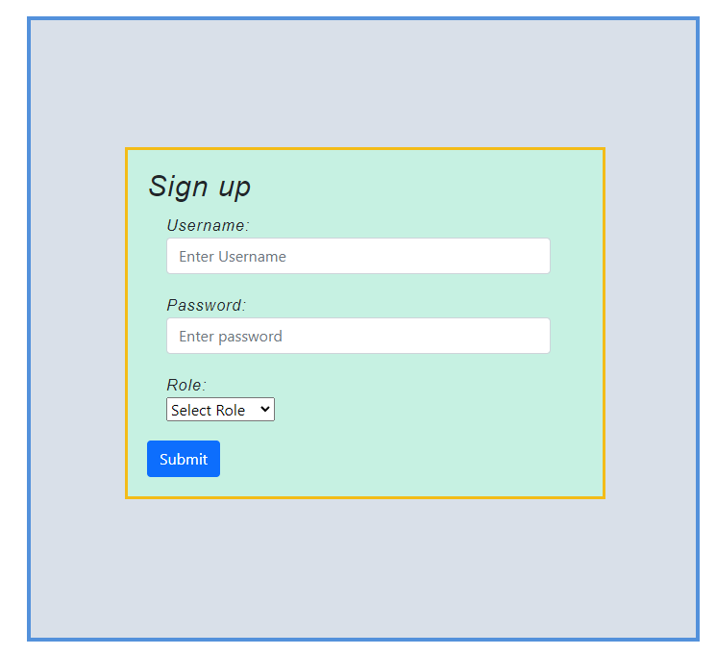

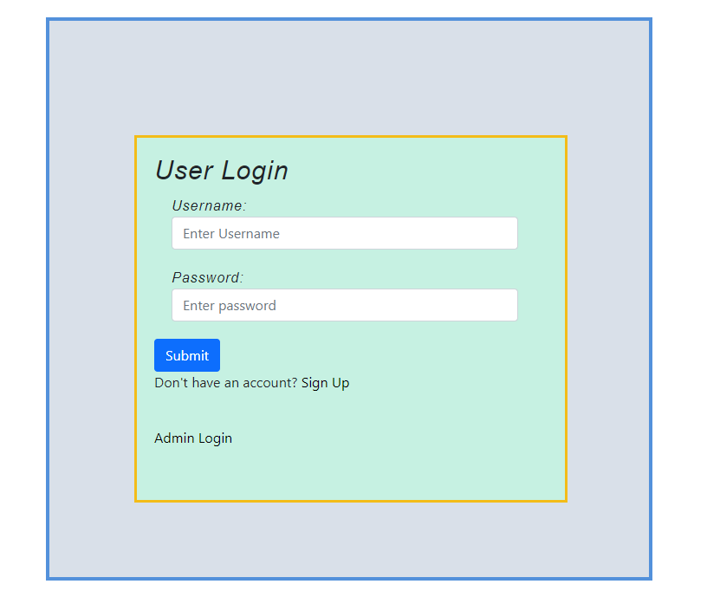

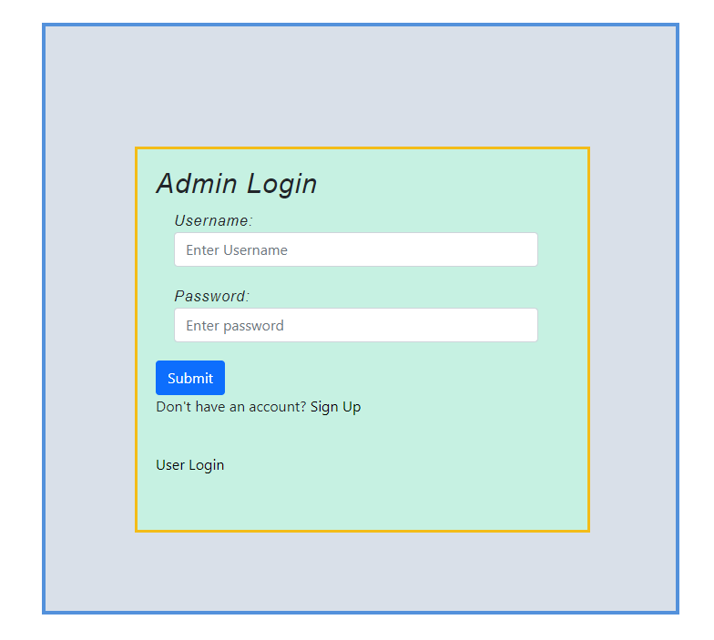

All Users

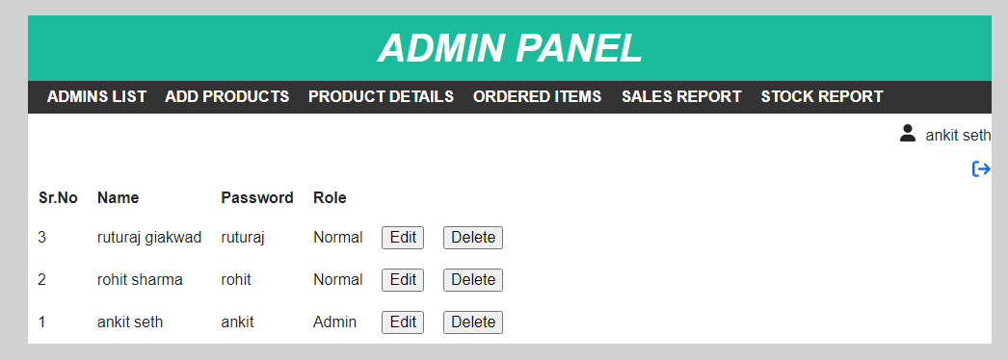

Add Products:

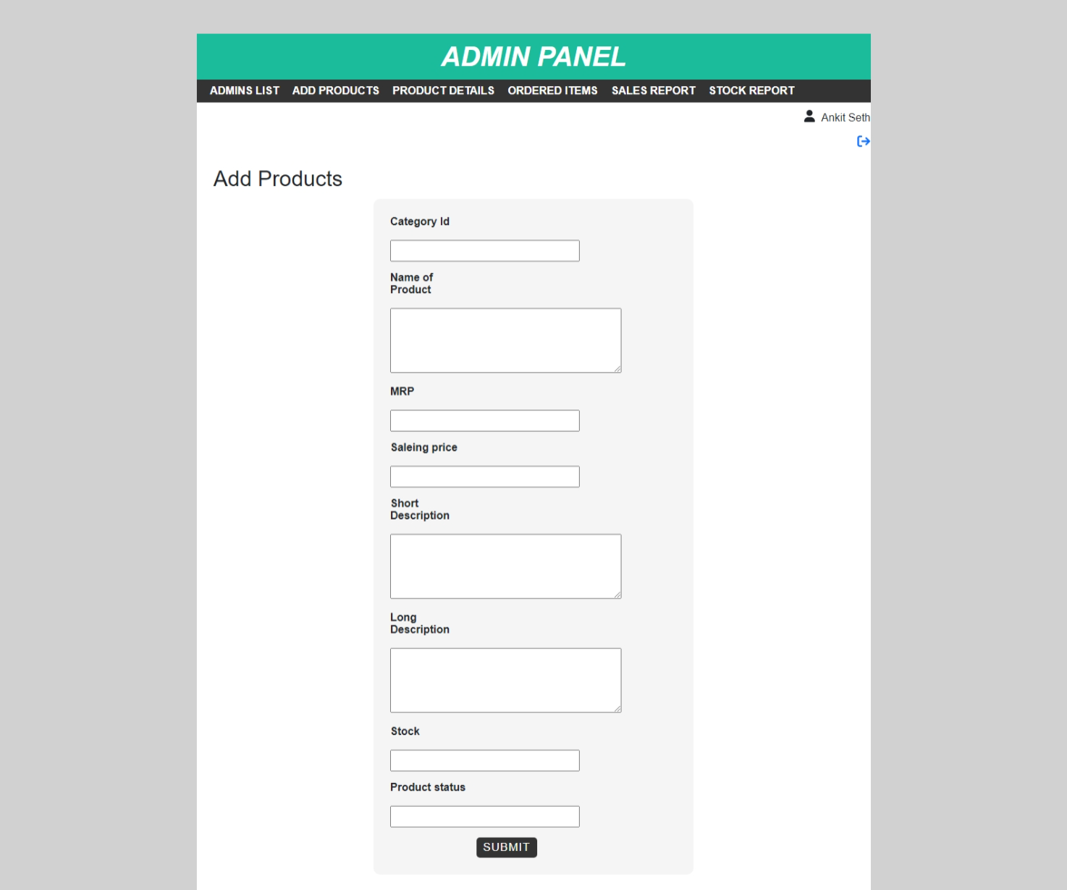

Products Details:

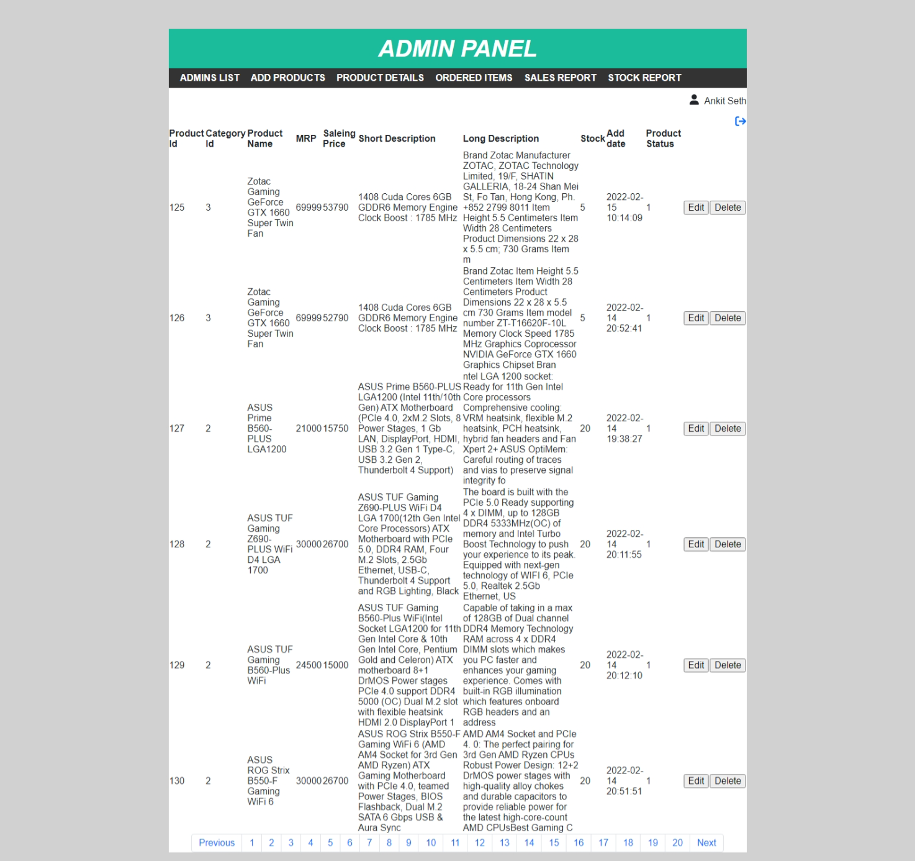

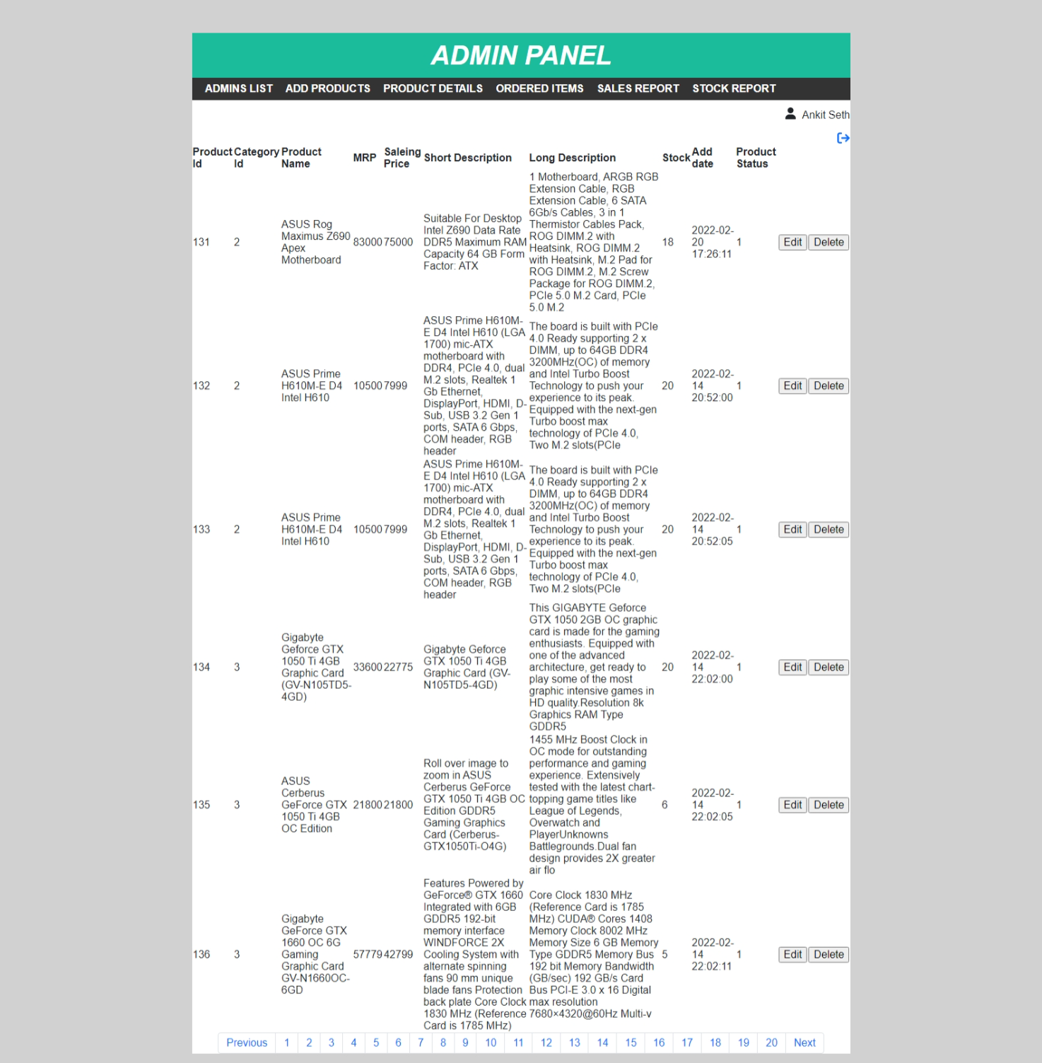

All orders till date:

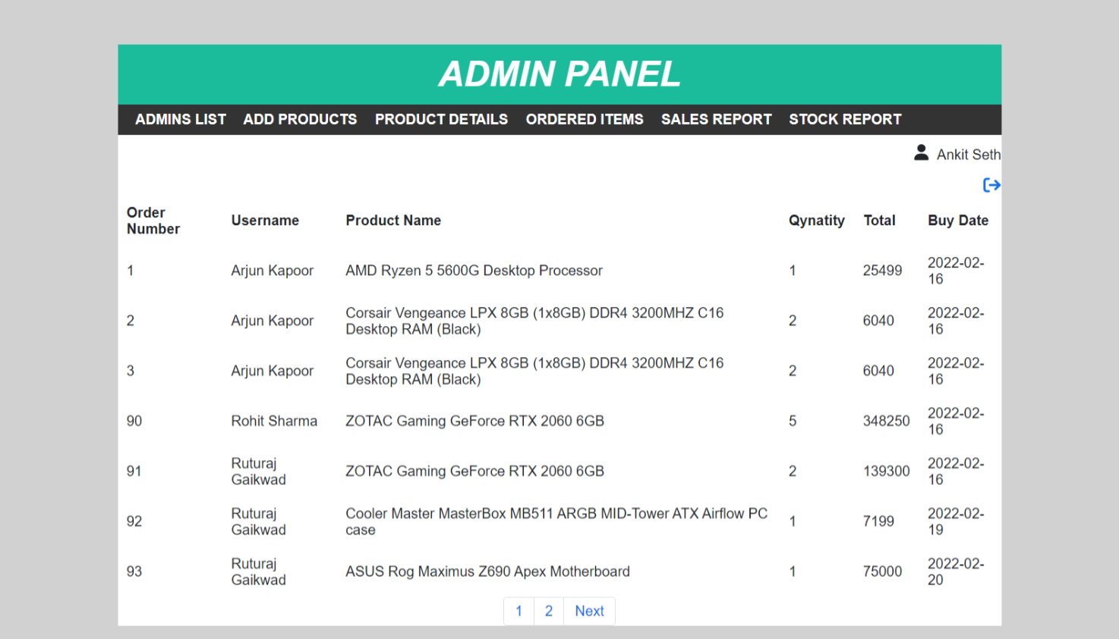

User’s Side

Home page:

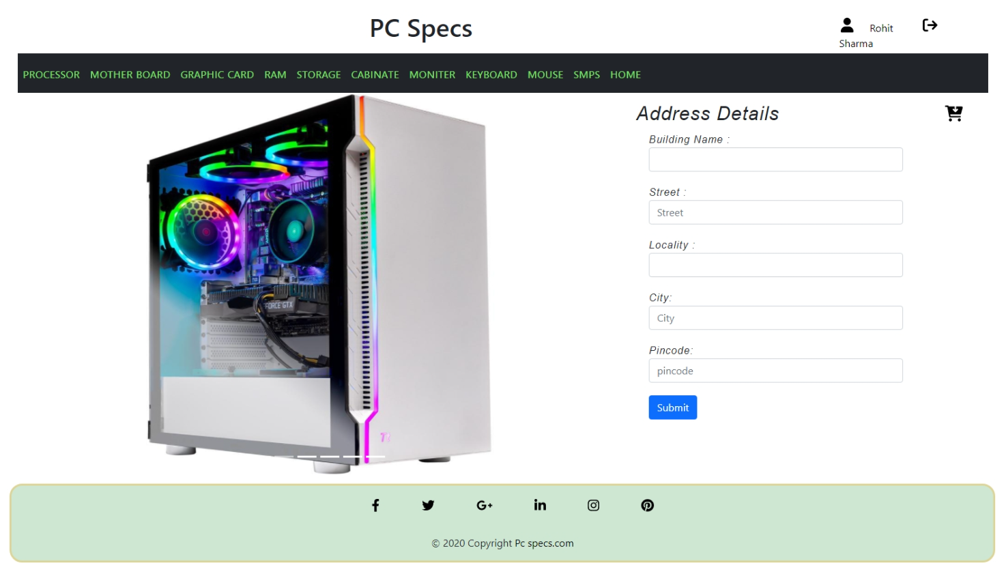

Profile:

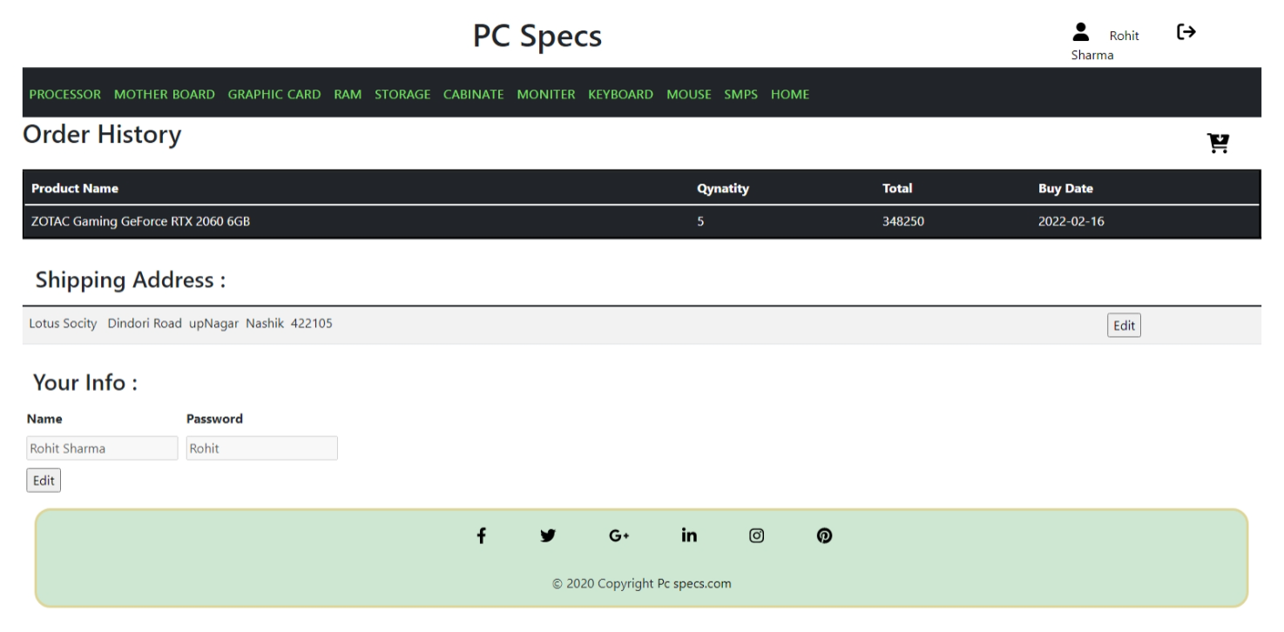

Cart :

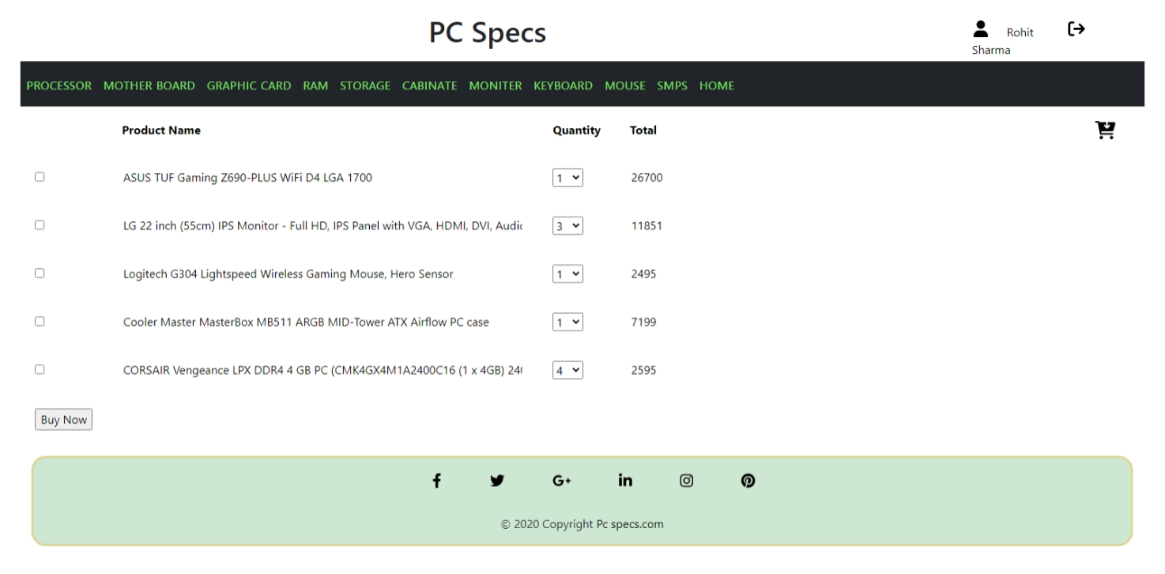

Order Summary:

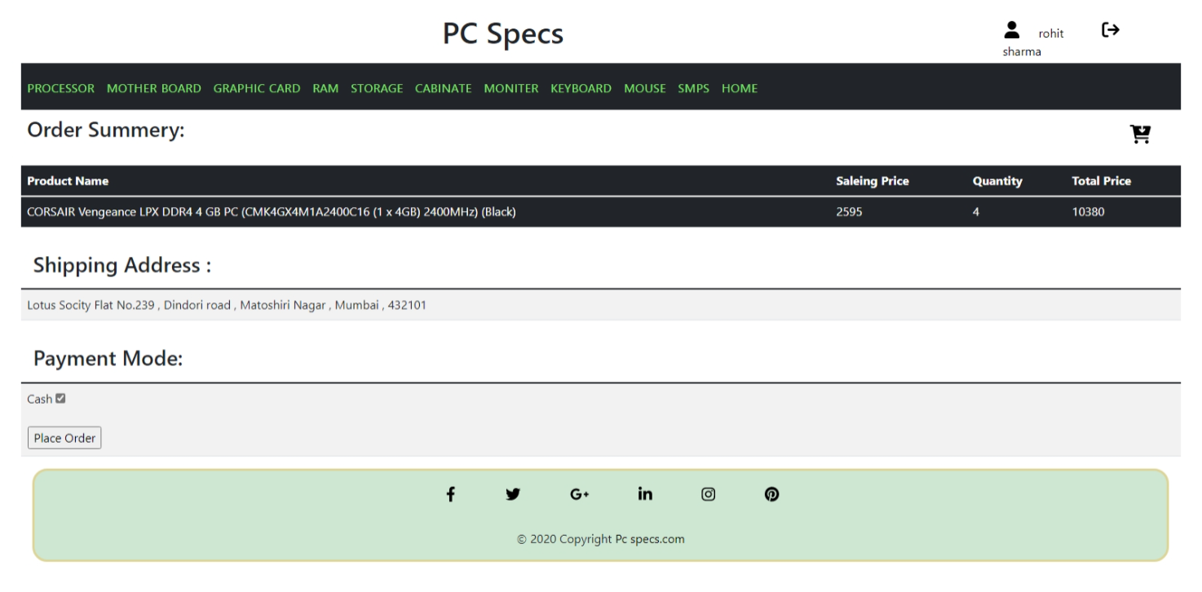

Bill:

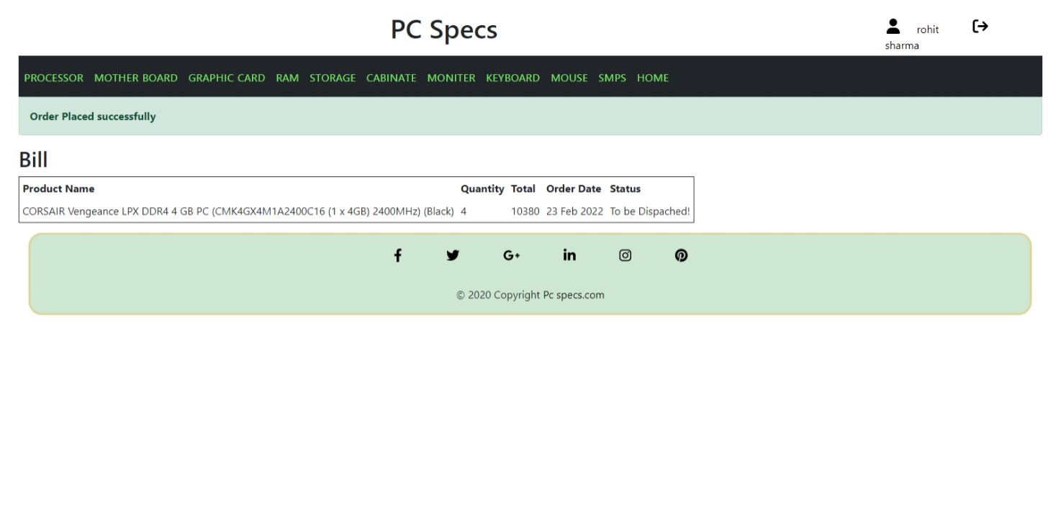

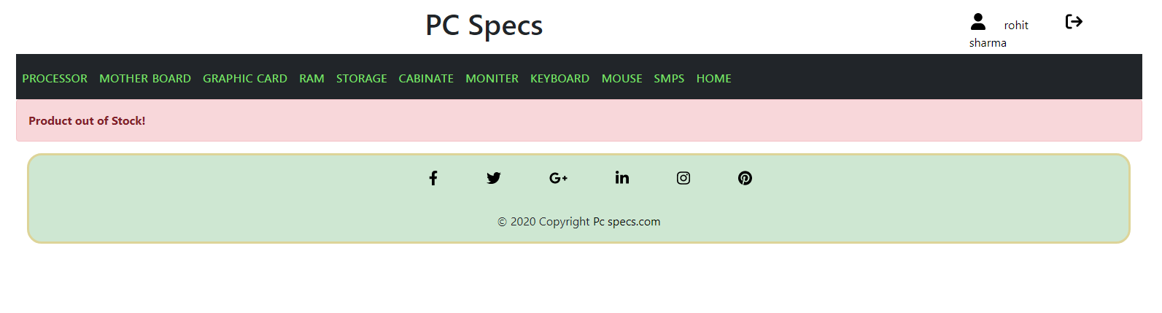

Product Details:

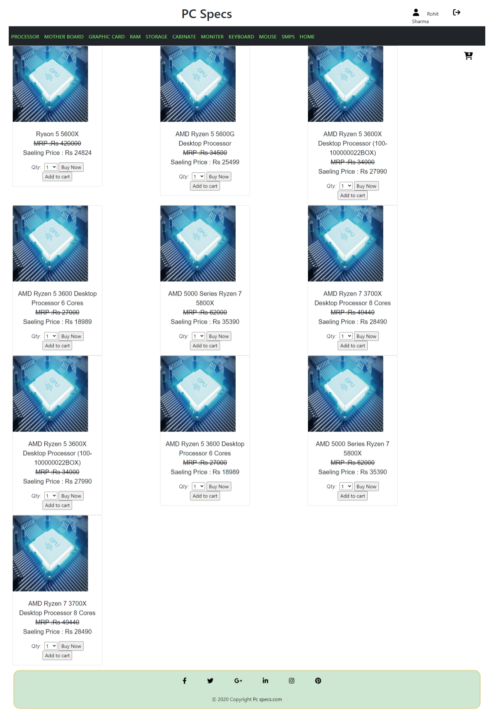

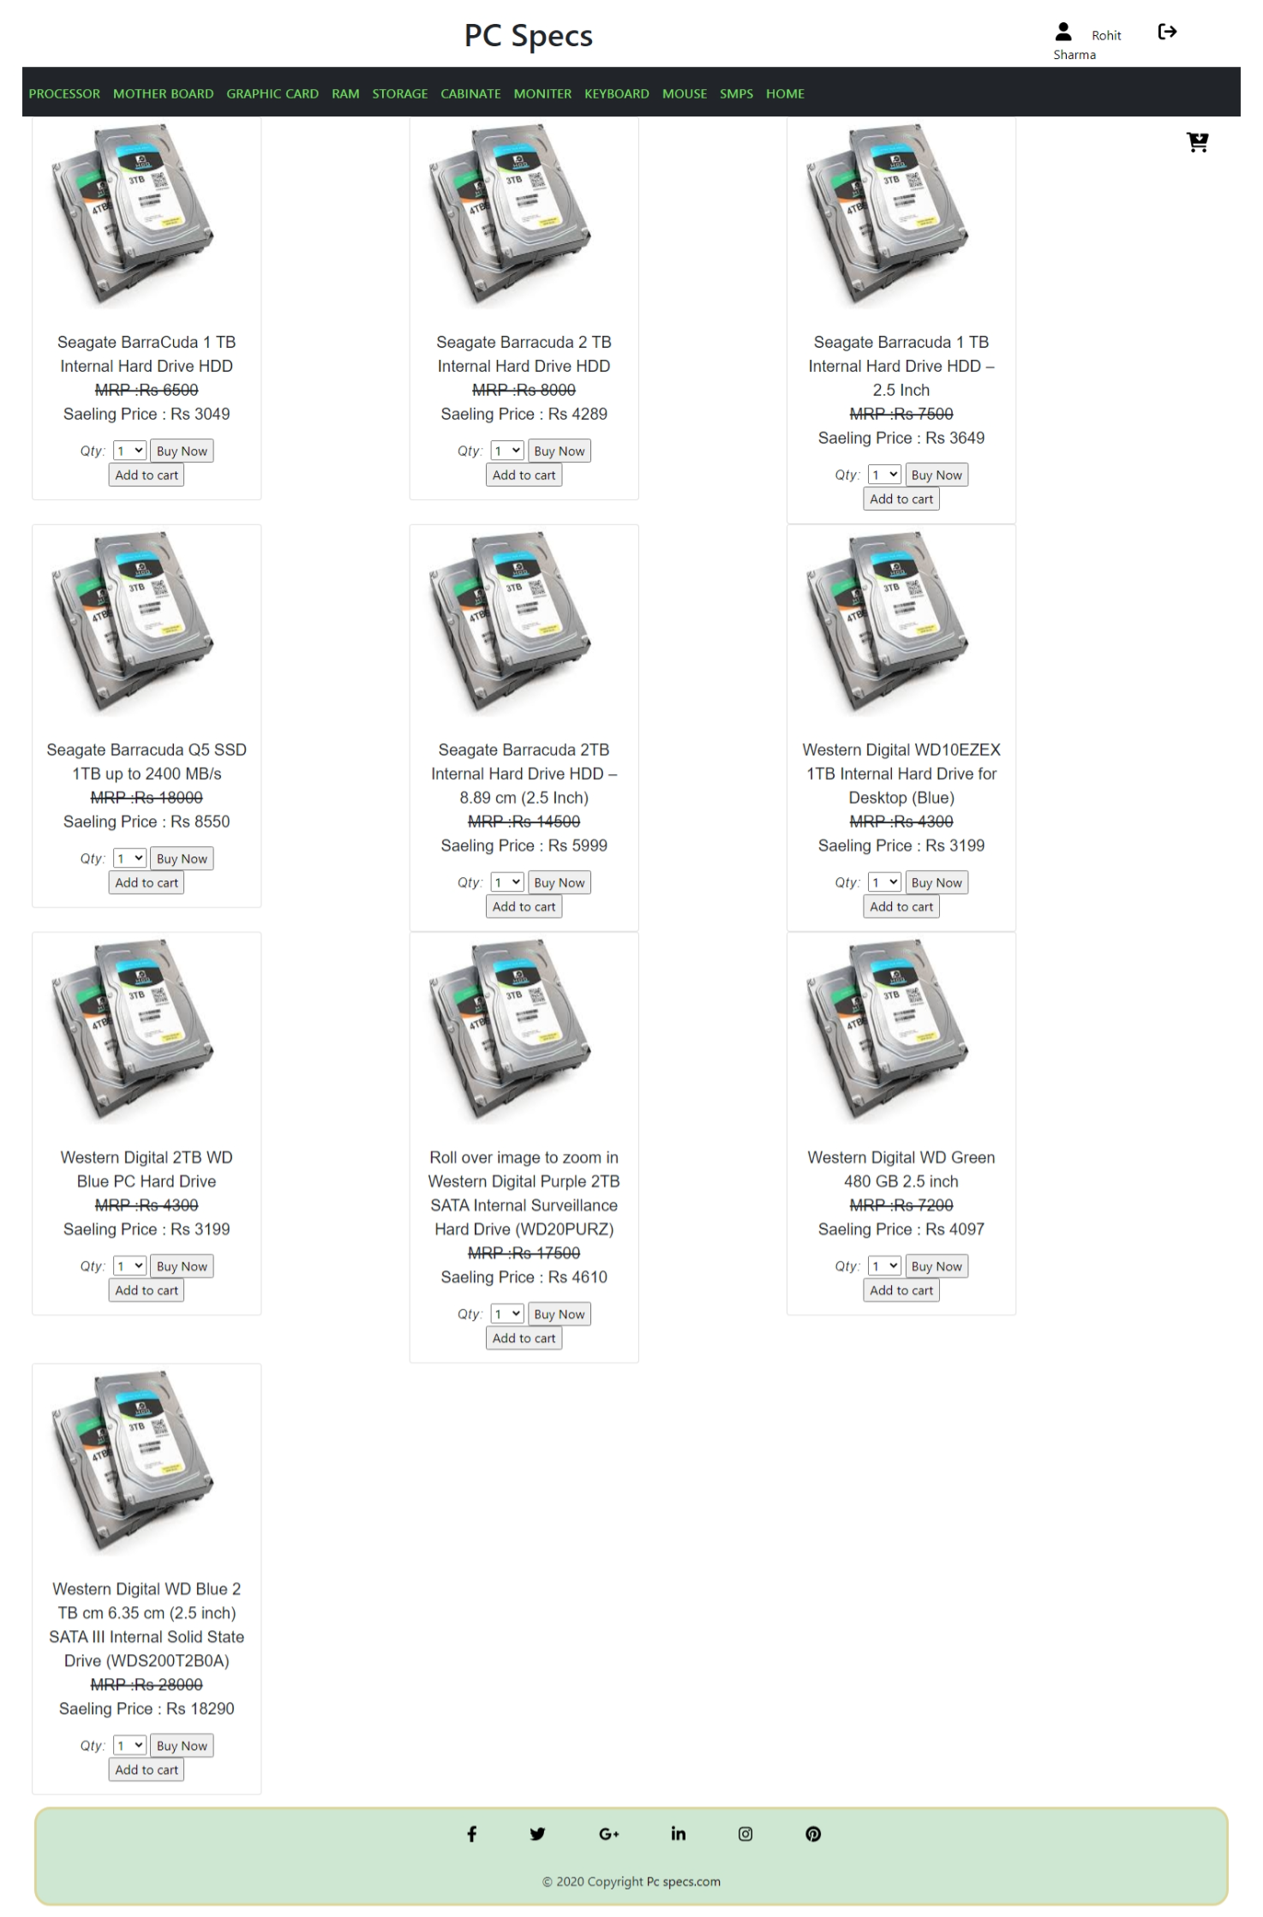

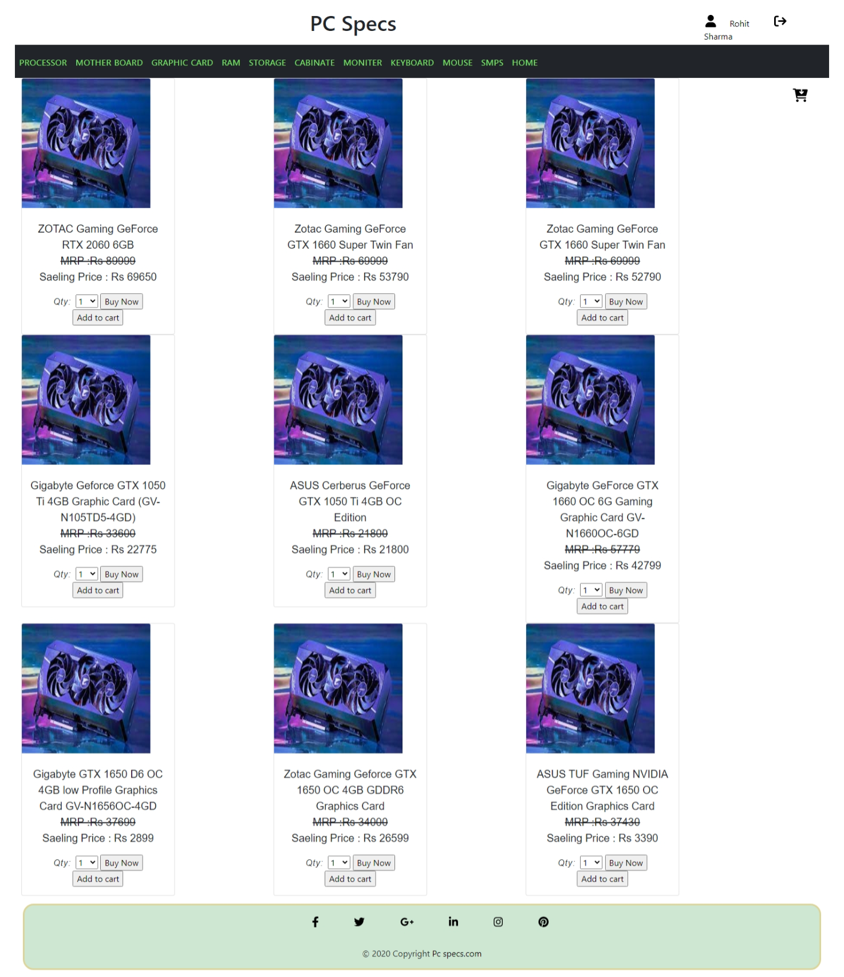

**Implementation details**

* This web site can run on a low specification PC.
* The system must contain at least
* 4 GB RAM.
* 500 GB storage capacity.

**Outputs and Reports Testing**

Sales Report:

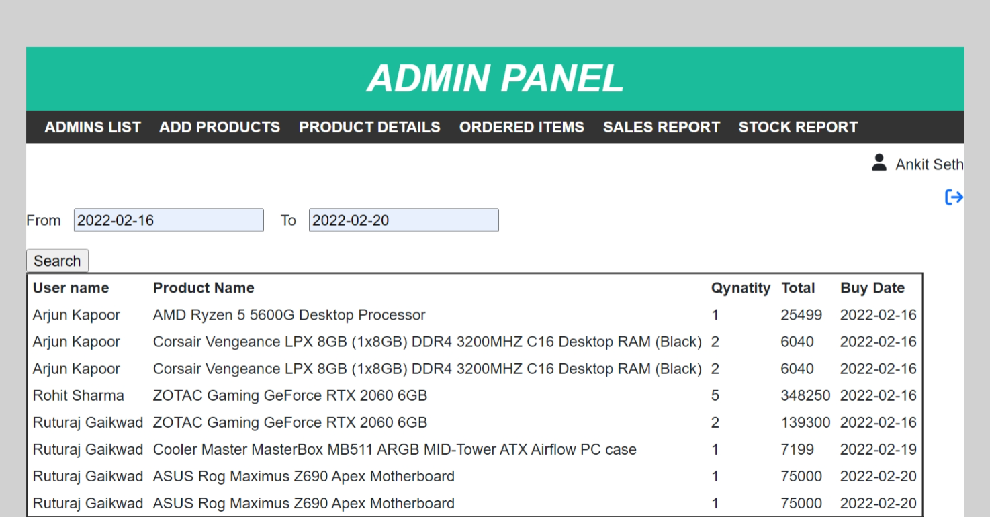

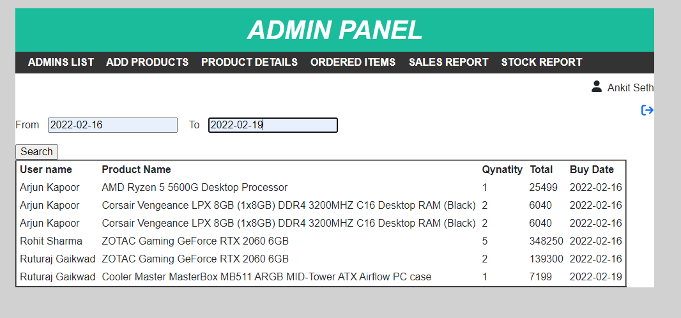

Stock Report:

